**Geting started with ros**

for this report the folllowing versions of OS ans ROS is used:

* ubuntu 20.04 LTS
* ROS foxy fitzroy

**Connecting your base station(laptop) to Raspberry pi:**

there are three ways to do this :

1. Connect raspberry pi to the same network the base station(laptop in this case) is connected to. However this has some issues:
   * its not very relaible
   * incase if you wanted to change your testing location,it wont be possible with this.

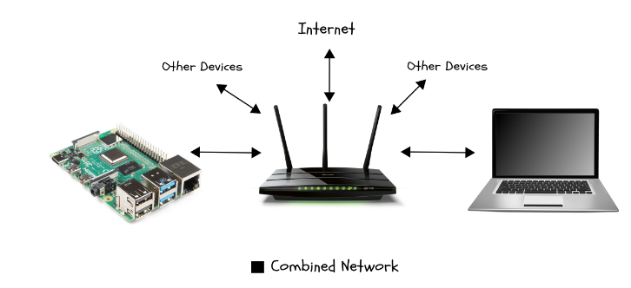

1. AD-HOC/AP Network: this also has some issues that are
   * it is not easy to setup
   * it will not be possible to easily swap base stations

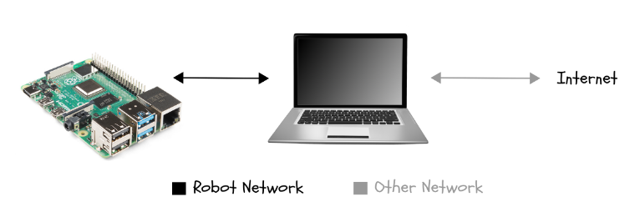

3. Using a dedicated method :

* here we use something called a travel router (a switch) ,that will allow us to create a small private network for our base station and our raspberry pi. This travel router will be connected to the internet source directly

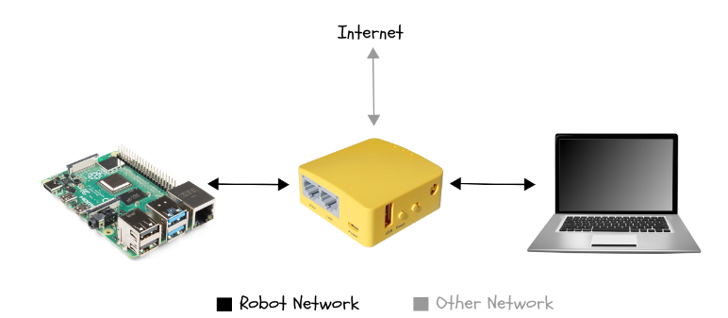

**Installing ROS2**

please refer to this link <https://docs.ros.org/en/foxy/Installation/Ubuntu-Install-Debians.html>

for a better understanding of how its done, however i shall include the main steps involved in it below, it is best that the documentation is referred for this















finally after all this install colcon build tool



**ROS consists of mainly three things :**

1. nodes

2. topics

3. services

**Nodes ?**

These mini pograms that run simultaeneosly, you can also consider them as driver programs for each sensor

**Topics ?**

A node either publishes or subscribes to this, you can consider this as a channel for inter node communication

**Services ?**

It is mainly used for triggerring certain events , for example: stopping the motor on a lidar when its not being used , or putting the IMU into sleep mode when not in use, etc.

**Making packages in ROS**

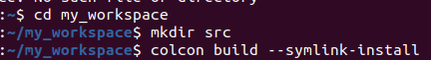

* replace my_workspace with whatever name you wish to name your directory
* then use the colcon tool to build your directory and make ROS compatible



* use the pkg create command to make ur custom package , replace my_custom_package with whatever name you like to give it

**Transforms**

* **Transformations (or more simply, "transforms") express an object's position and orientation in relation to another.**
* ****Transform tree****
  + **Transforms define the translations and rotations needed to get from a source frame to a target frame whether it's parent-to-child, child-to-parent, or across multiple "generations" of frames. A complete set of a scene's transforms, from the base frame to all its related children, constitutes a **transform tree**.**
* **There are two types of transforms :**
  + **static transform (these dont change over time, they remain constant)**
  + **dynamic transform (these change over time)**
* ****Static transforms****

An example of a static transform





View it on rviz

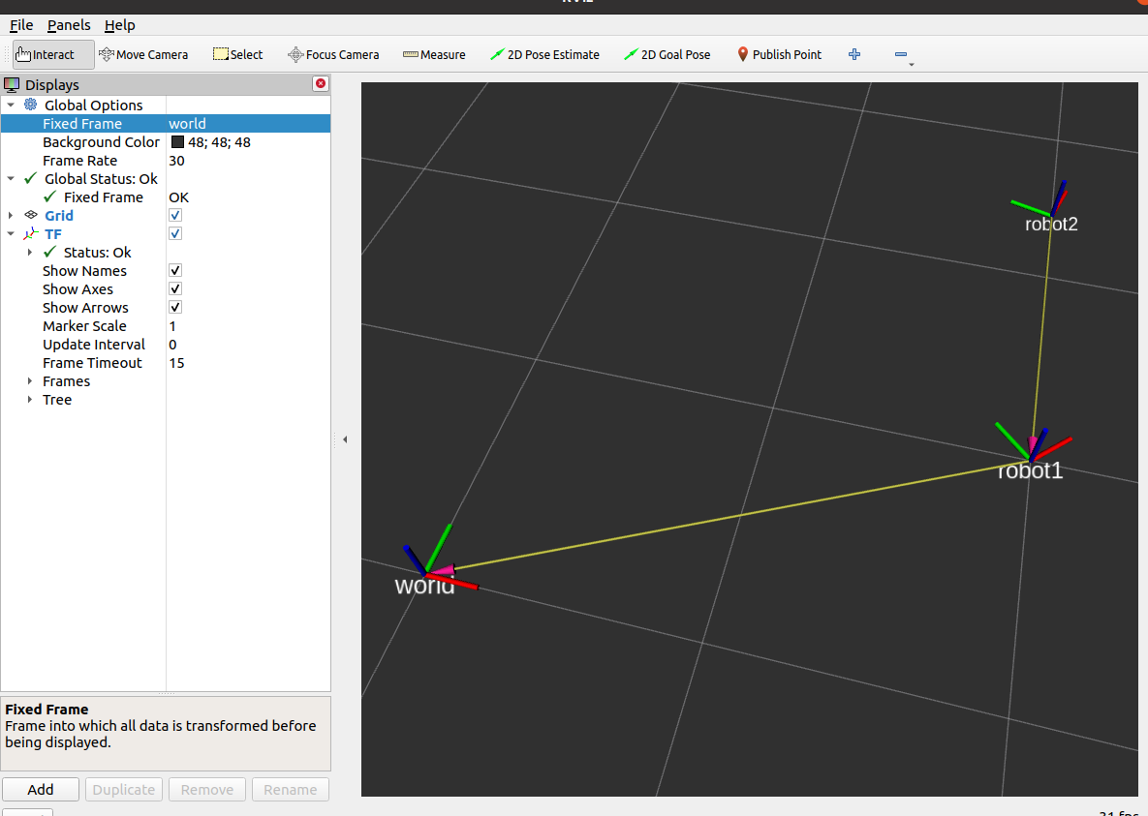

* ****Dynamic transforms****

dynamic transforms change over time , we shall induce this change using a another package called joint_state_publisher_gui , this is plugin that will publish values directly in the /joint_states topic. The next section covers an example related to this topic, for just install the plugin using the command below



****Basic introduction to URDF files****

**here i will be explaining only simple and important xml tags that are needed to get started , but while defining the robot structure in the next section of this report , a slightly more advanced structure would be used.**

* ***What is a URDF file used for ?***
* URDF describes a robot as a tree of links, that are connected by joints. The links represent the physical components of the robot, and the joints represent how one link moves relative to another link, effectively defining the location of the links in space
* ***what are joints and what are links?***
* *Links:*

In ROS, a link represents a physical component or part of a robot. It can be considered as a rigid body with certain geometrical and physical properties. Links can represent components such as arms, legs, bodies, sensors, or any other physical part of the robot.

* Joints:

Joints define the connections between links in a robotic system, allowing them to move relative to each other. Joints represent the degrees of freedom of the robot and determine how the robot can move and articulate.

* **Some commonly used joints are :**

1. **Continuous**- A rotational motion with no limit (e.g. a wheel).
2. **Prismatic**- A linear sliding motion, with minimum/maximum position limits.
3. **Fixed**- The child link is rigidly connected to the parent link. This is what we use for those “convenience” links.
4. **Revolute**- A rotational motion, with minimum/maximum angle limits.

**In a Urdf file the links are defined using the <link></link> tags and the joints are defined using the <joint></joint> tag. Each link has three porperty tags:**

1. **<visual> :it defines the external looks of the object it also has three properties <geometry>,<origin>,<material>**
2. **<collision> : it defines the collider that surrounds the mesh, it can be of any shape , or you can even define a collider specifically for the mesh. This also has three separate properties that are similar to the visual tag**
3. **<inertial> :it defines the physics aspect of the object , that is mass, center of gravity and the rotational matrices . This also has three tags that are <mass>,<inertia >,<origin>**

****What is . xacro ?**it makes using URDF files much more easier ,eg: we don’t have to repeat a lot of code we can just use a simple include tag and keep reusing it**

**The three things that xacro help us separate are :**

* **properties**
* **Mathematical operators**
* **Macros(these are template files that can be reused )**

**A sample macro that I would be using in this report will be for defining the inertial tags of some commonly used links ,looks like:**

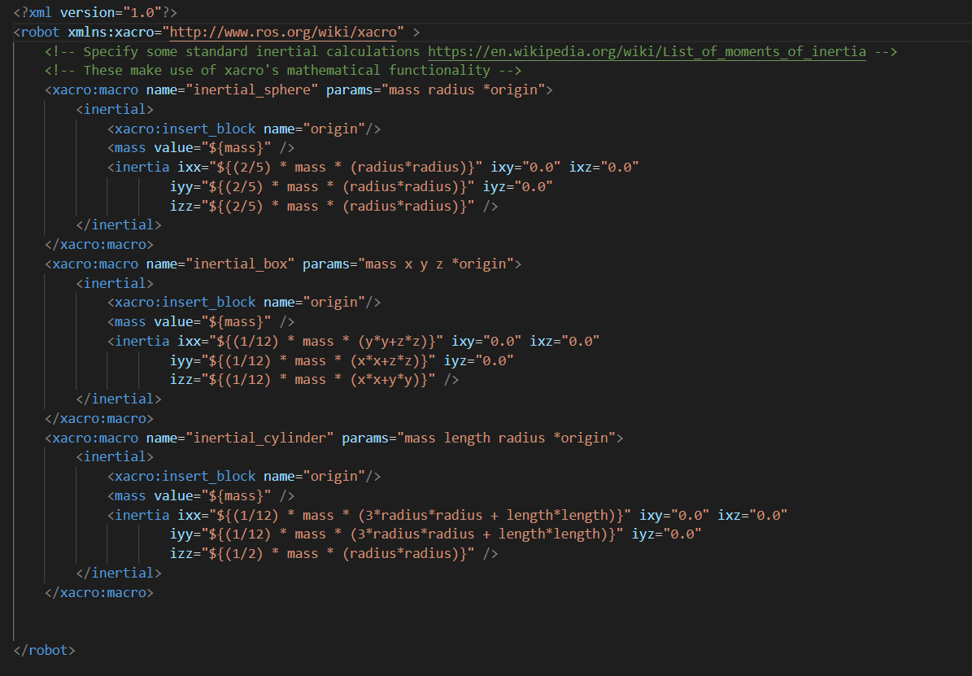

* for the purpose of our understanding lets create a sample robot ,using URDF file and control its joint_states using the joint_state_publisher_gui (Note as this is in rviz , I wont be using the inertial macro shown above, the inertial macro should be use used only when simulating robots in gazebo)

**In this case I shall demonstrate how to create a simple robotic arm with 3 DOF**

1. **Source your ros directory**



1. **Create and build your directory**







1. **Create a custom package , and build it again (my_bot in this case)**

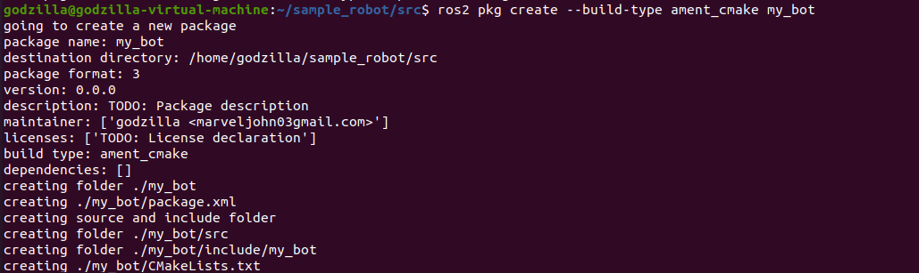



1. **Open vs code in your working directory(sample_robot in this case), and change the file system a bit ,and update the ‘CMakeLists.txt’ file to whats given below**

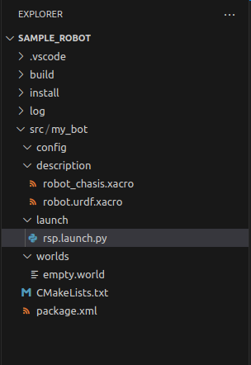

**Please note** the way this directory is made up, make sure you update your custom package directory to this , after u have done ros2 create pkg command.(I will be using this same style of file system, throughout the contents of this report)

**Note:** The CMakeLists.txt needs to be updated to this:

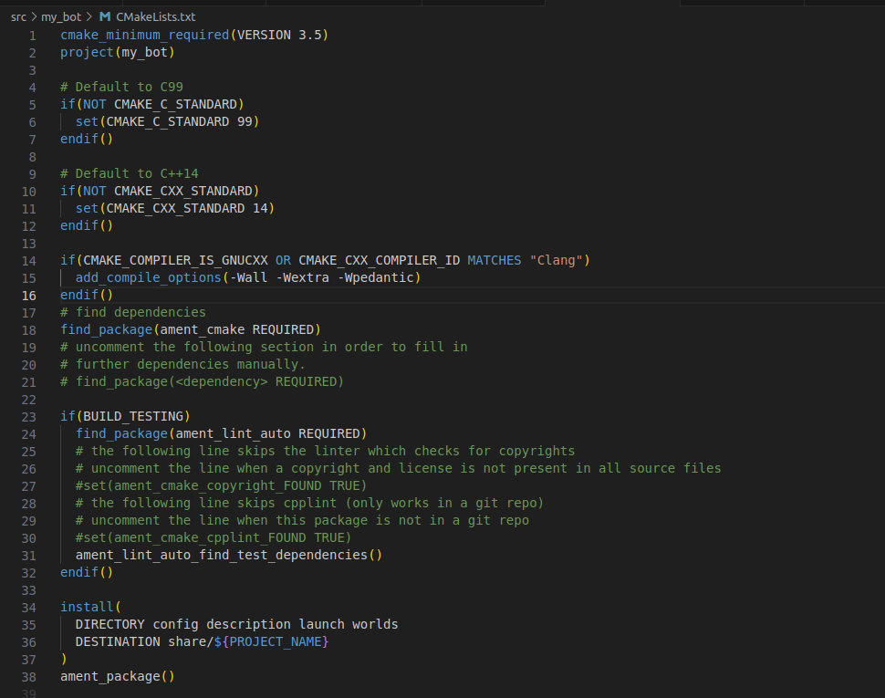

1. **Start designing ur robot in a xacro file (in this case I have named it as ‘robot_chasis.xacro’) , after you can include this file in another xacro file (in this case ‘robot.urdf.xacro’)**

**The robot_chasis.xacro file**

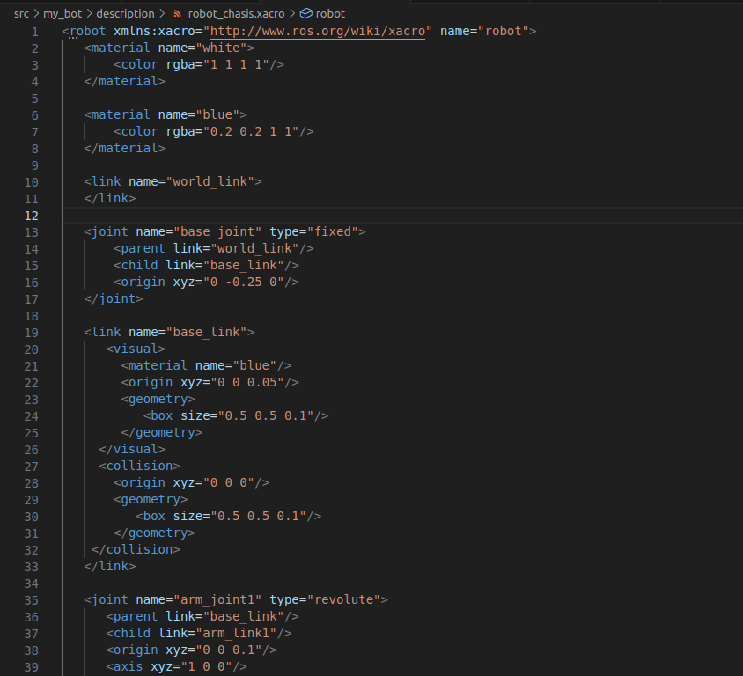

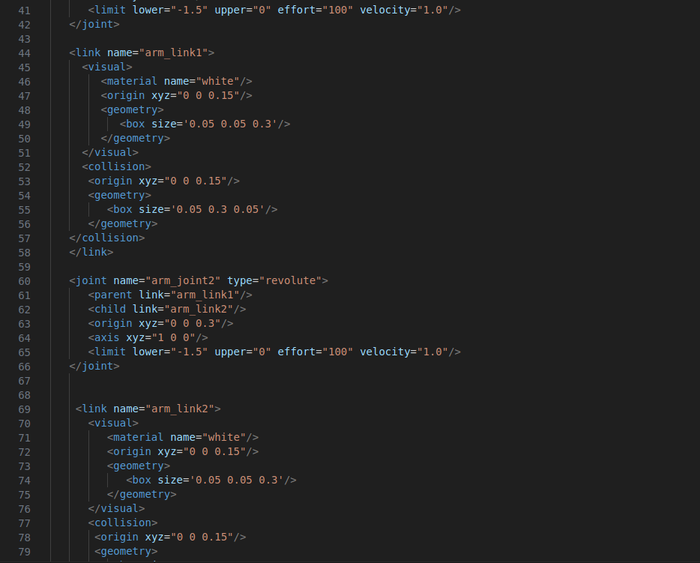

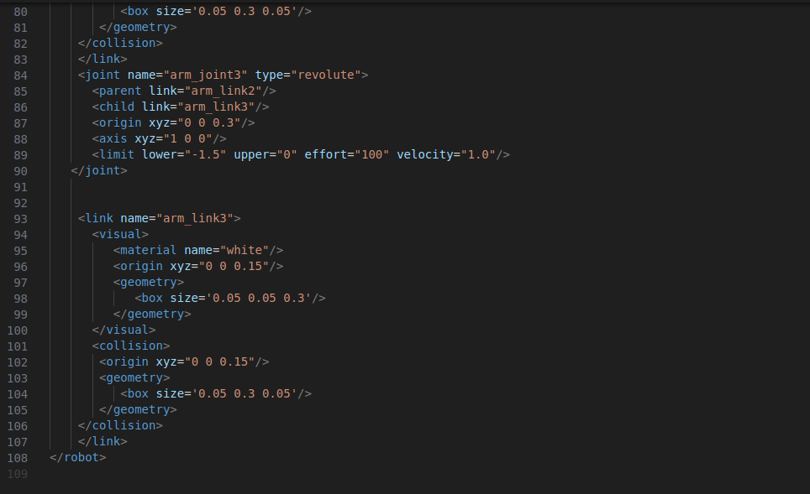

The robot.urdf.xacro file

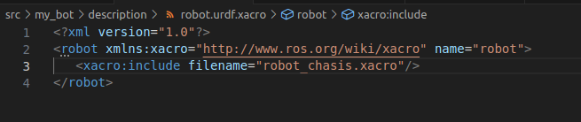

1. **Update your launch based on how your directory is setup in my case , the launch file is called rsp.launch.py , and it looks like this**

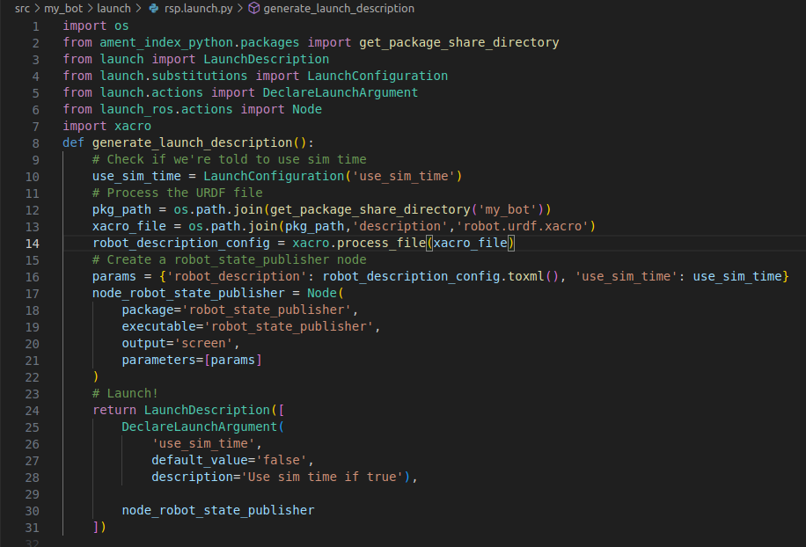

1. **Run your file using the launch command , and open rviz and joint_state_publisher_gui to see your desired output**

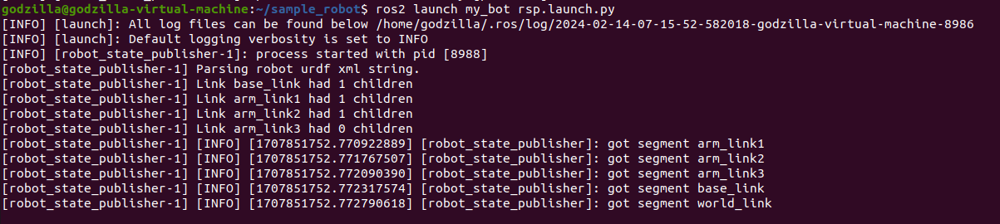



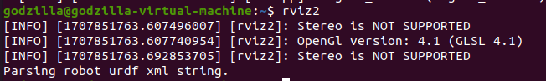

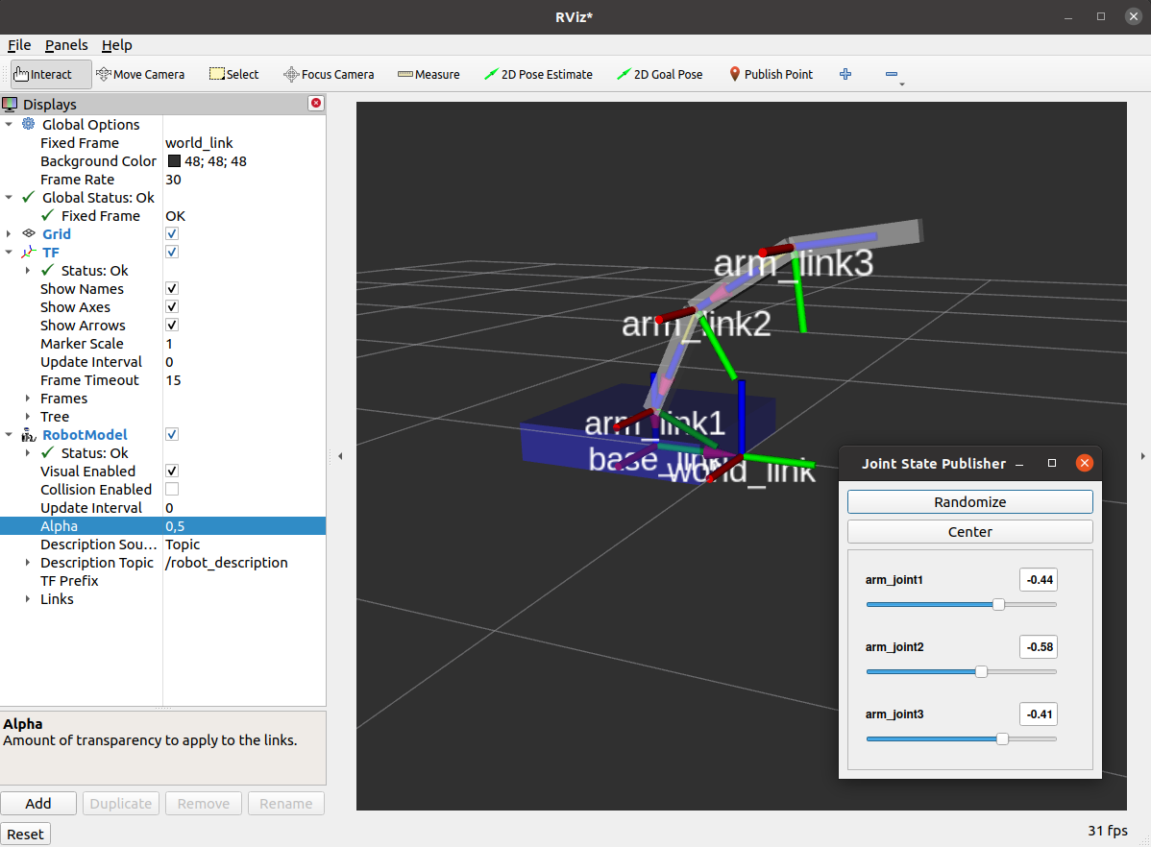

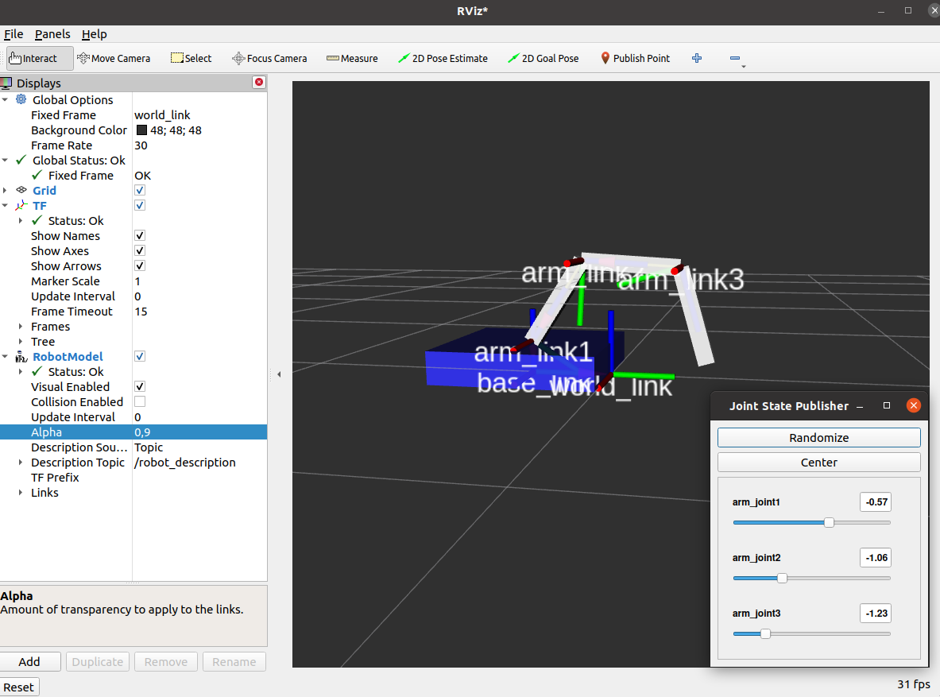

**Designing the robot**

there are four stages to designing of a mobile robot:

* **phase 1:**

1. concept design (simulations)

* **phase 2:**

1. assembling the hardware components, which include :
   * raspberry pi
   * power circuitry
   * motors
   * 2d lidar
   * camera

* **phase 3:**
  1. designing and assembling the chassis
* **phase 4 :**
  1. steering control
  2. advanced teleop
  3. mapping and navigation
  4. object tracking

however due to time limitations , i shall limit this report to only implementing most of these phases in simulation (using gazebo) only

**Setting up our workspace**

the working directory wil be called robot_v1.0 in this report and package will be called articubot_one

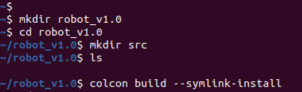

**Note:** before you start working with ros ,make sure its been sourced

* first source the directory in which ros is installed



* second source your working directory

Displaying the robot on rviz , and giving input using the **joint state publisher gui**

Installing the joint_state_publisher_gui

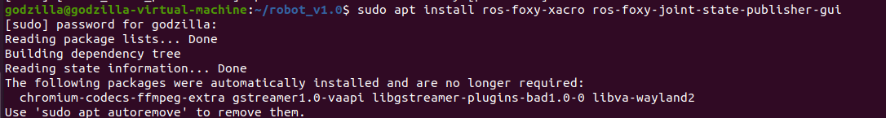

Running it



Launching the robot model via the launch file

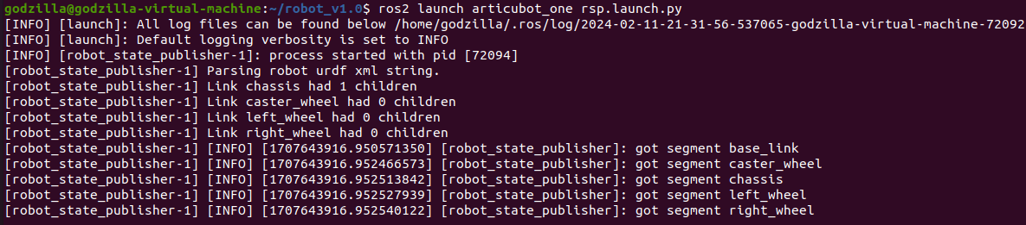

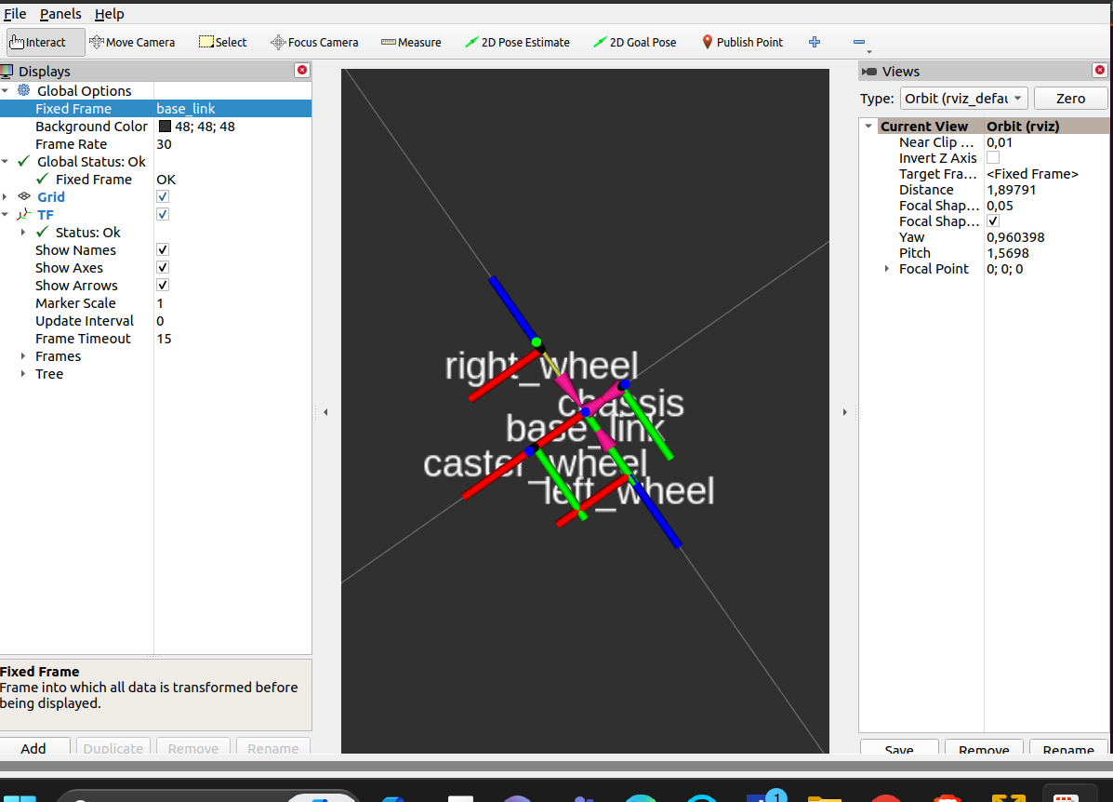

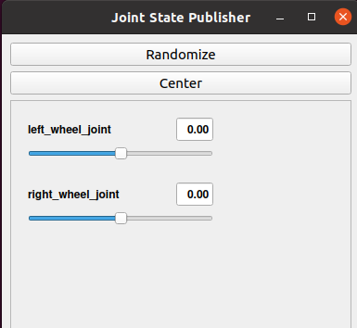

**Spawning the robot in gazebo**

**Using the launch file(please make sure to make the use_sim_time:=true )**

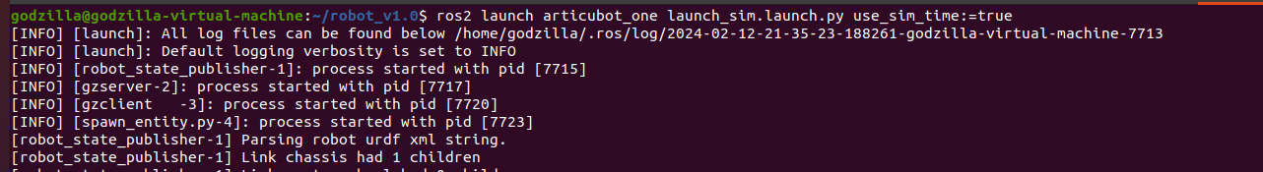

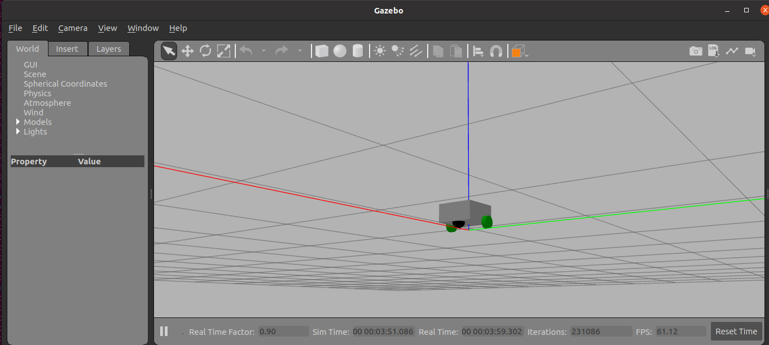

**Using the spawn entity command(in case if the above method doesn’t work)**

* Launch gazebo using the in-built launch file



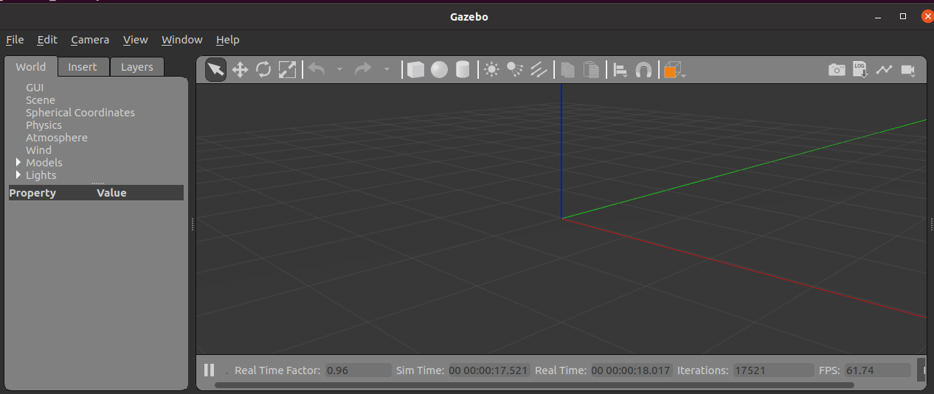

* Spawn your robot using the spawn command (u can replace my_bot with any name you like, and “robot_description” is the topic where the urdf file is being published, if its different is your case the please change it )



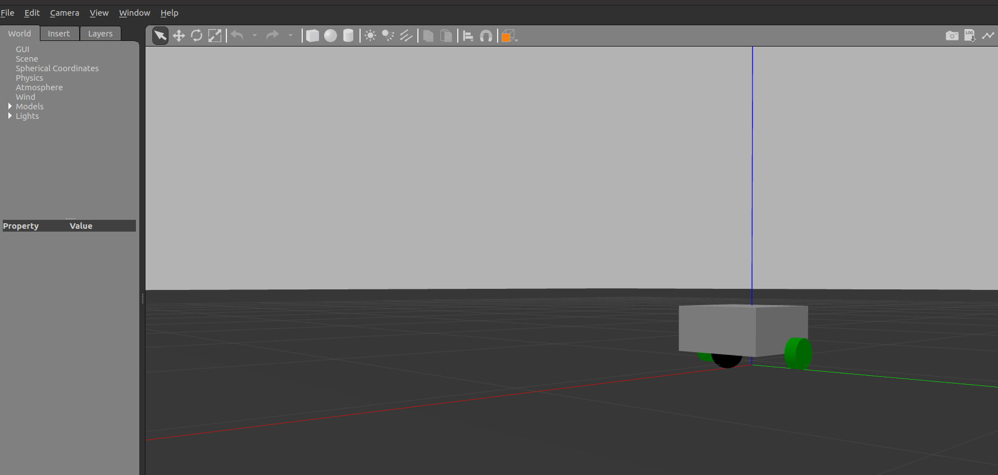

**Adding sensors to the robot**

1. **LIDARS**

Lidar, short for Light Detection and Ranging, is a remote sensing method that uses light in the form of a pulsed laser to measure variable distances to the Earth. Lidar technology operates on the principle of emitting rapid pulses of laser light towards the target and measuring the time it takes for the light to return after reflecting off the object. By calculating the round-trip time and knowing the speed of light, lidar systems can accurately determine the distance between the sensor and the object.

* There are currently three types of lidars :
* **1 dimensional lidars:** 1D lidars, specialized in measuring distances along a single line, emit laser pulses in one direction and measure the time it takes for the pulse to return, providing accurate distance information. These lidars find frequent use in industrial automation and robotics, where tasks such as object detection and obstacle avoidance require straightforward distance measurements along a specific axis. Although simpler and more cost-effective compared to their 2D or 3D counterparts, 1D lidars are best suited for scenarios where measurements along a single dimension suffice, limiting their application to situations where a broader perspective is unnecessary.
* **2 dimensional lidars:** 2D lidars, in contrast to their 1D counterparts, are capable of scanning laser beams in multiple directions, typically covering a two-dimensional plane. They emit laser pulses and measure the time it takes for the pulses to return after hitting objects from various angles, thereby generating detailed 2D representations of the surrounding environment. These lidars are extensively used in robotics, autonomous vehicles, and mapping applications, where a comprehensive understanding of the surroundings is essential for navigation, obstacle avoidance, and localization. Despite being more complex and costly than 1D lidars, their ability to capture a wider field of view makes them indispensable in scenarios requiring a broader perspective and higher spatial resolution.
* **3 dimensional lidars :**3D lidars are advanced sensors that extend the capabilities of 2D lidars by providing detailed three-dimensional representations of the surrounding environment. They emit laser pulses and measure the time it takes for the pulses to return after hitting objects from multiple angles, covering a full 360-degree horizontal field of view and sometimes capturing vertical information as well. These lidars are crucial components in applications such as autonomous vehicles, robotics, urban planning, and virtual reality, where precise spatial understanding is vital for navigation, object detection, and mapping. Despite being more complex and expensive than their 2D counterparts, 3D lidars offer unparalleled accuracy and richness of information, making them indispensable tools in various fields requiring comprehensive 3D mapping and analysis capabilities.

Lidar systems are utilized across various fields including atmospheric research, geology, archaeology, forestry, urban planning, and autonomous vehicles. In atmospheric research, lidar is used to measure the distribution of aerosols, clouds, and pollutants in the atmosphere. In geology and archaeology, lidar helps in creating detailed topographic maps and identifying buried features such as archaeological sites or geological formations. In forestry, lidar can provide precise measurements of tree height, canopy structure, and biomass. In urban planning and autonomous vehicles, lidar is crucial for generating detailed 3D maps and for object detection and navigation.

**Simulating lidars using ros2 in gazebo**

* We create a new file in our directory called lidar.xacro , which will contain all the information regarding the sensor in it

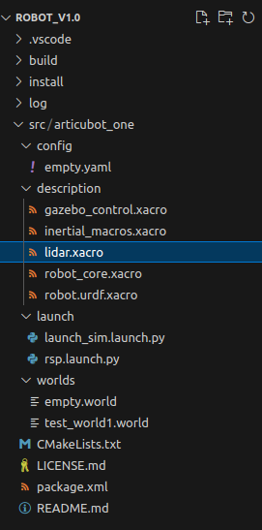

* And this file will be included in our main robot.urdf.xacro file, and this file will be launched through our launch file

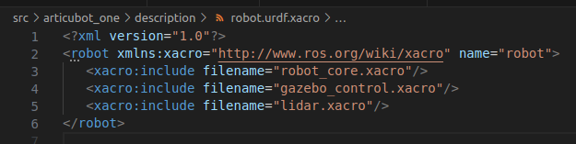

* On running the launch file we get



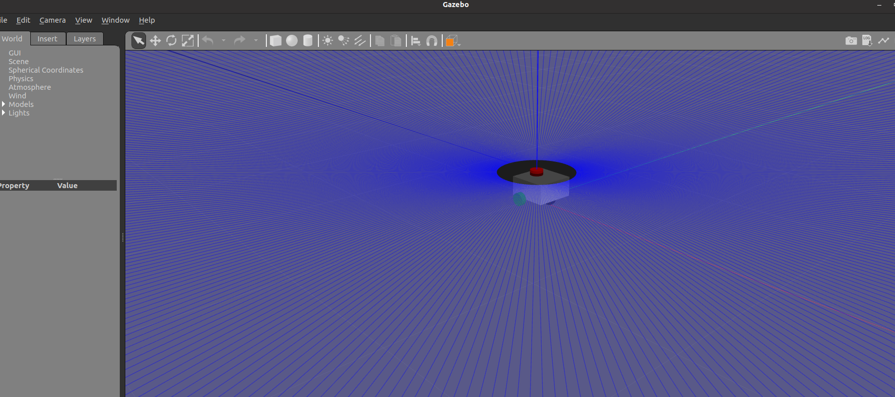

* Lets add a world file with this and re launch it



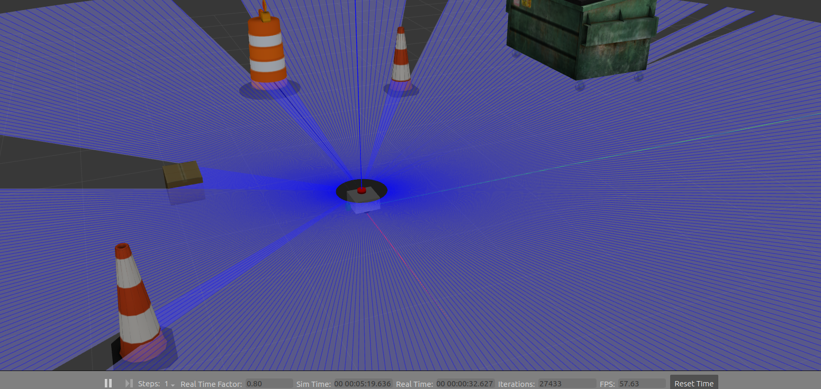

Note: if u want to change the visibility of the laser scans in gazebo(the blue rays, you see being traced, make the visibitly tag as false,in the lidars.xacro file )

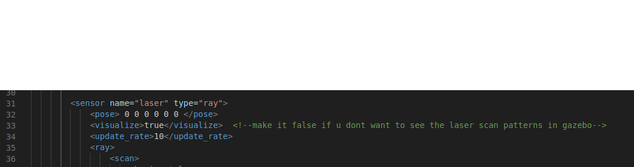

We can drive this robot around in gazebo using the teleop_twist_keyboard plugin just to check if everything works(please note: this is not the same as ros2_control module, use this plugin to only check the working of the sensors )

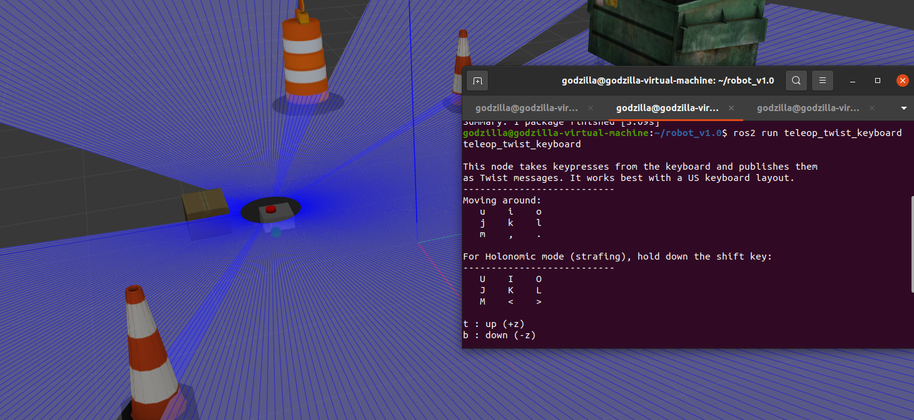

* Now all this laser data is being published in a topic called ‘ /scans ’, so first add the laserScan plugin into your rviz

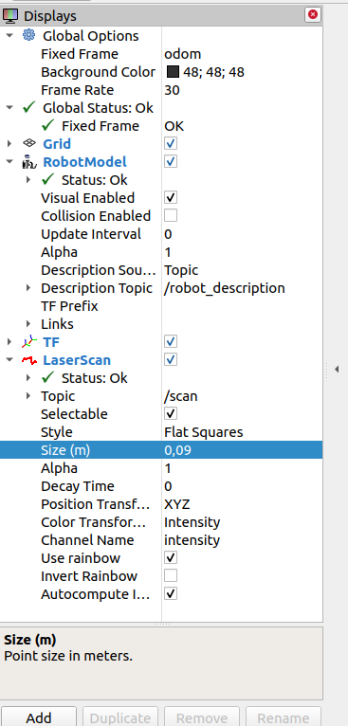

A side by side comparison of the sensor’s behaviour

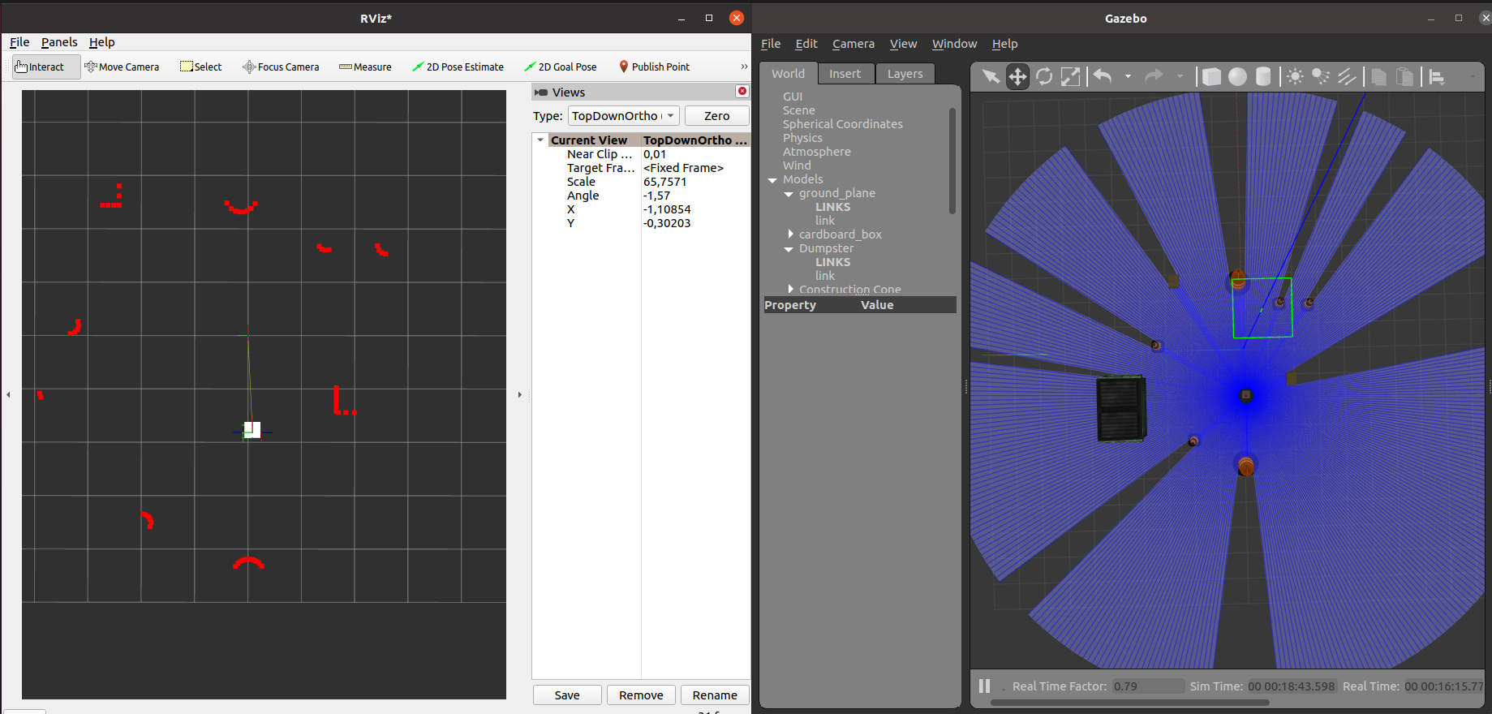

1. **Cameras**

Cameras are widely used in robotics for various purposes due to their ability to capture visual information. Here are some key reasons why cameras are essential components in robotic systems:

* Perception and Sensing
* Object Recognition and Tracking
* Scene Understanding
* Human-Robot Interaction
* Visual Feedback and Control

In order to simulate this in gazebo, we create another file called ‘camera.xacro’ and add it to our ‘robot.urdf.xacro’ file , this file will contain all the information regarding the sensor , and its parameters.

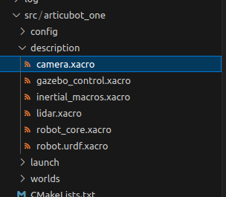

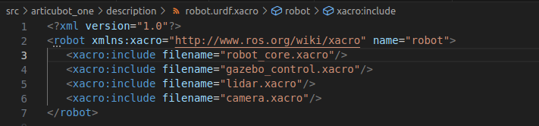

Now after making the neccesary changes ,build your directory using the colcon build command

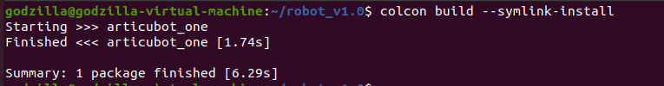

Now use launch file(I'm using the launch file directly in this case, you can also separately spawn your robot into gazebo ,if you have multiple models)



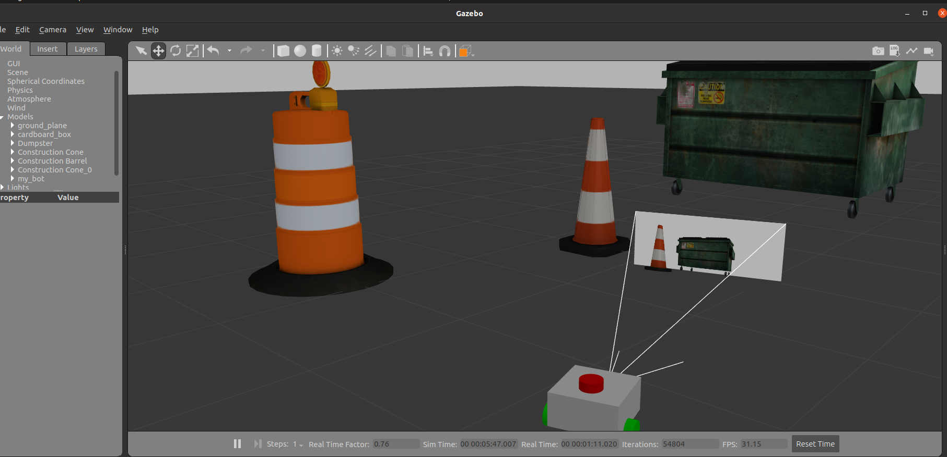

**Please note:** I have made the visibility tag of the lidar to false, due to which the laser rays aren’t visible anymore

**Getting the output in rviz**

the sensor scans get published under sensor_msgs/Image (in case if its an uncompressed image), so add the Image plugin topic in your rviz , and select the topic , /camera/image_raw , to see the camera output

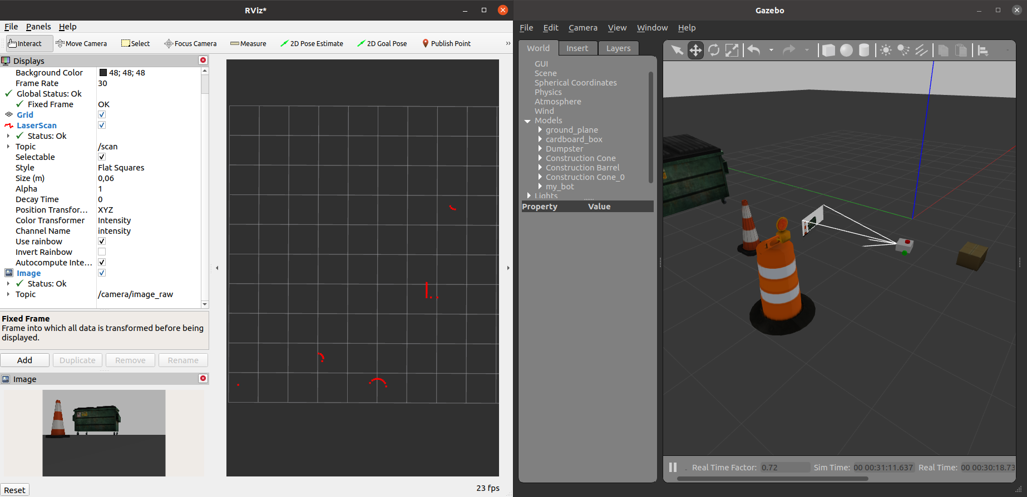

Notice: that the laser scans(lidar data) is still working, so turning the visibility to false, doesn’t mean the lidars is turned off

Points to note here:

1. Currently we are only printing uncompressed image, as rviz doesn’t support compressed images
2. In real life situations, depending on the camera driver node ,it will publish either compressed image or else uncompressed image . So in case if it publishes compressed images we cannot let it publish the image on sensor_msgs/Image topic ,as we wont be able to decompress it in order to get the original image back
3. So these compressed images would be published into another topic ,ie: sensor_msgs/compressedImage , we can then retrieve the decompressed image from our sensor_msgs/Image based on whatever compression you have defined(eg: jpeg,png,etc)
4. Inorder to view this compressed image we use a different approach, as it will be discussed below

So inorder to deal with compressed images we use a plugin:

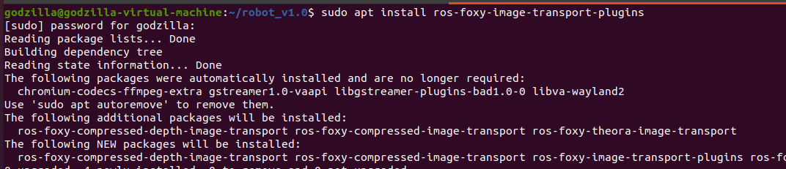

This will generate a set of new topics, that allow you to publish compressed images too

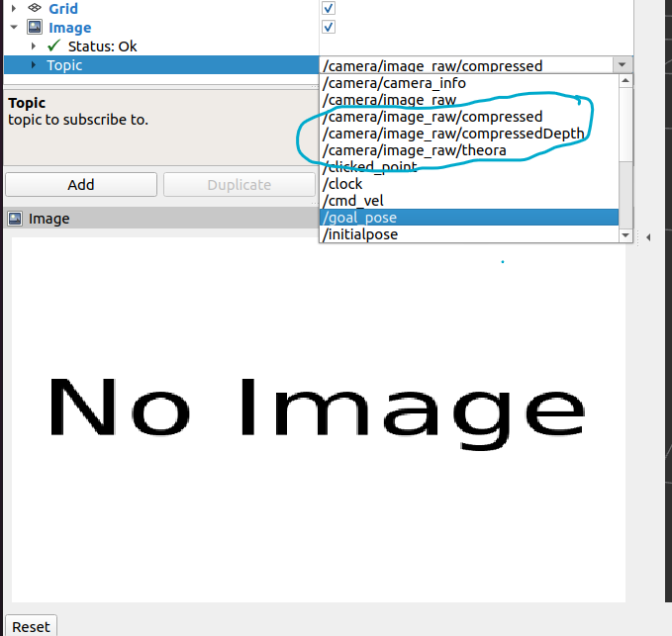

but notice how no image is being published, even though gazebo is sending it, this is because rviz doesn’t support compressed images

So inorder to view these compressed images being publised ,we use another plugin

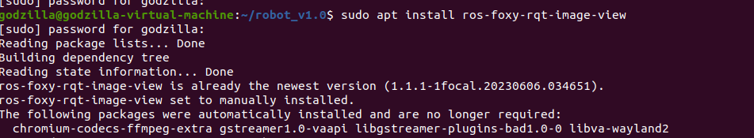



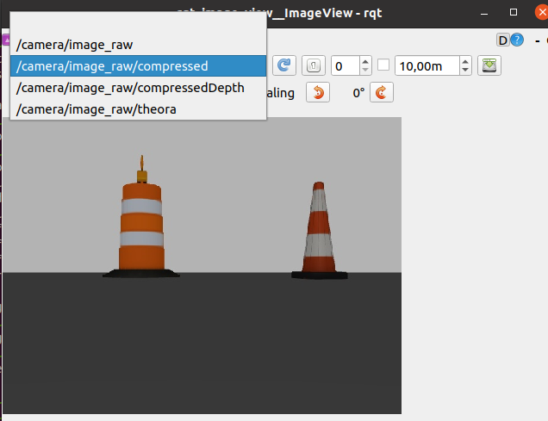

Now inorder to see our current design of our nodes and topics we can use

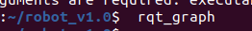

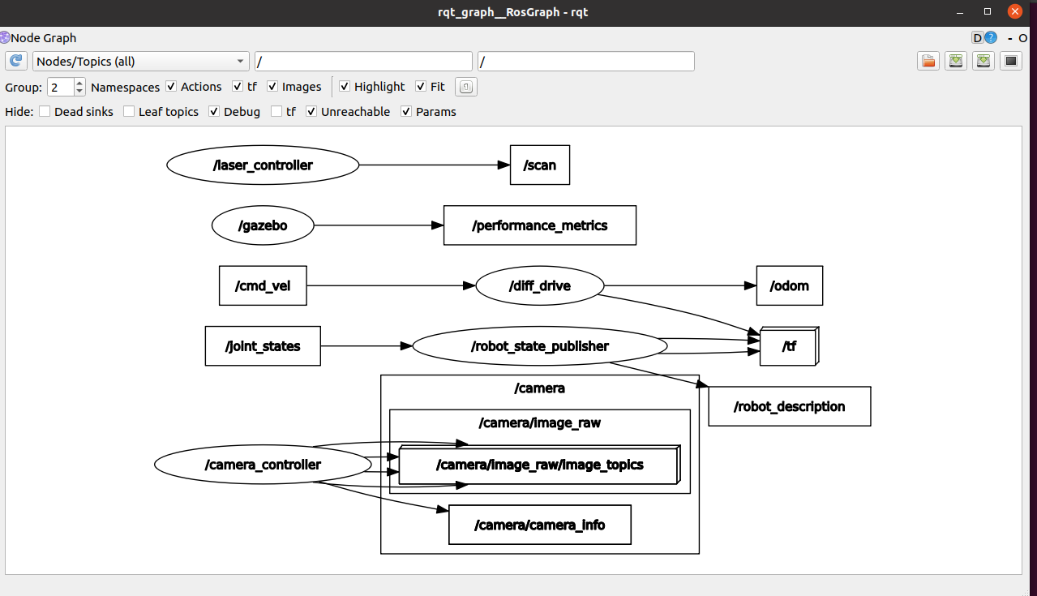

Notice here the camera data is being published into the /camera topic, and not the /Image topic so we can also use the camera topic plugin to view our image in rviz

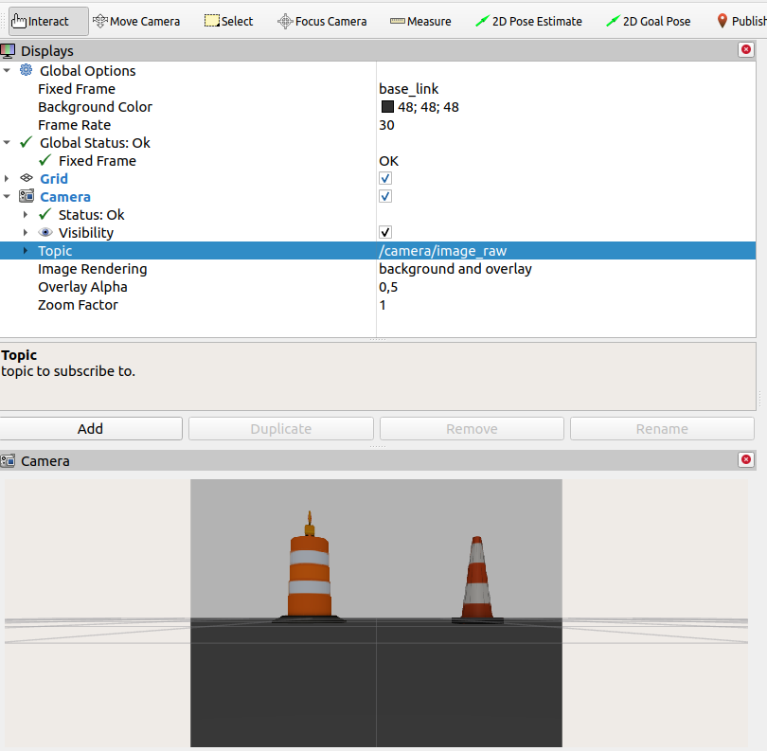

Hardware design and power requirements

